**EE230 – HW4 Report  
CMOS down-conversion Mixer**  
(@ 1.9 GHz & using 45nm CMOS Technology)

**Muhammad Aldacher**

**Student ID: 011510317**

1. **Schematic Setup:**

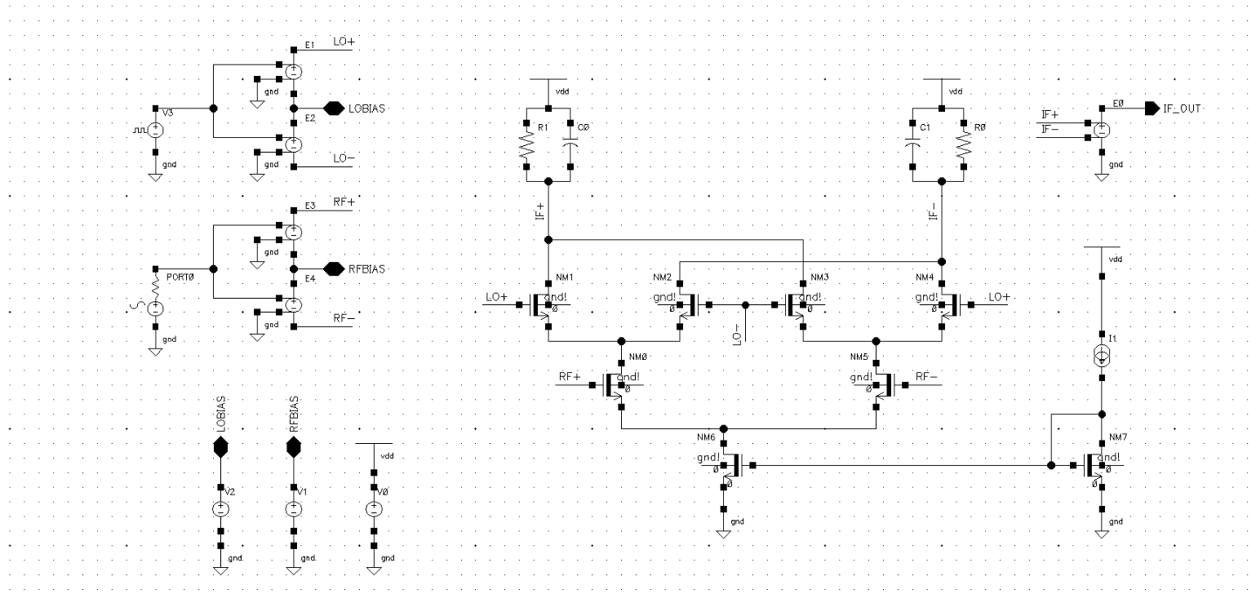

IF Output Port

LO Port

RF Port

**Fig. 1. Active Mixer schematic**

Table 1. Transistor parameters

|  |  |  |  |
| --- | --- | --- | --- |
| Transistor | W [um] | L [um] | Multiplicity |
| NM7 | 10 | 0.6 | 2 |
| NM6 | 15 | 0.6 | 20 |
| NM0, NM5 | 50 | 0.6 | 10 |
| NM1, NM2, NM3, NM4 | 15 | 0.15 | 10 |

Table 2. Component values

|  |  |
| --- | --- |
| Component | Value |
| R0, R1 | 600 Ohms |
| C0, C1 | 200 fF |
| IBIAS | 250 uA |
| LOBIAS | 0.9 V |
| RFBIAS | 0.7 V |
| VDD | 1.8 V |
| E0, E1, E2, E3, E4 | 0.5 V/V |

Table 3. RF port (left) & LO port (right) parameters

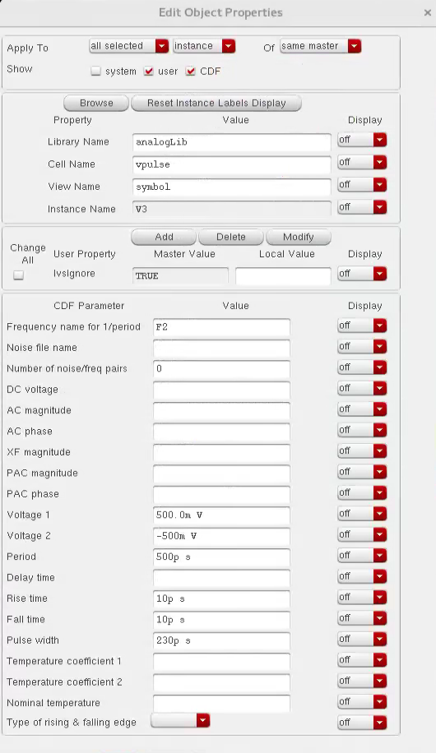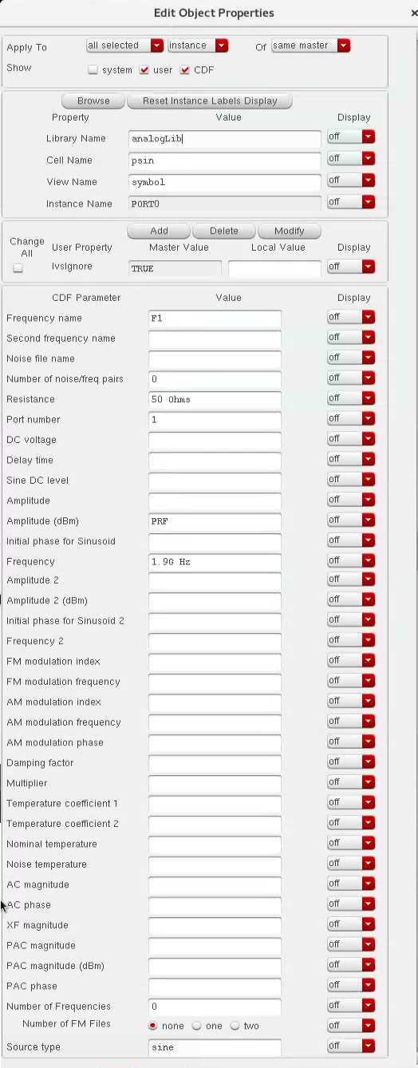

1. **DC operating points:**

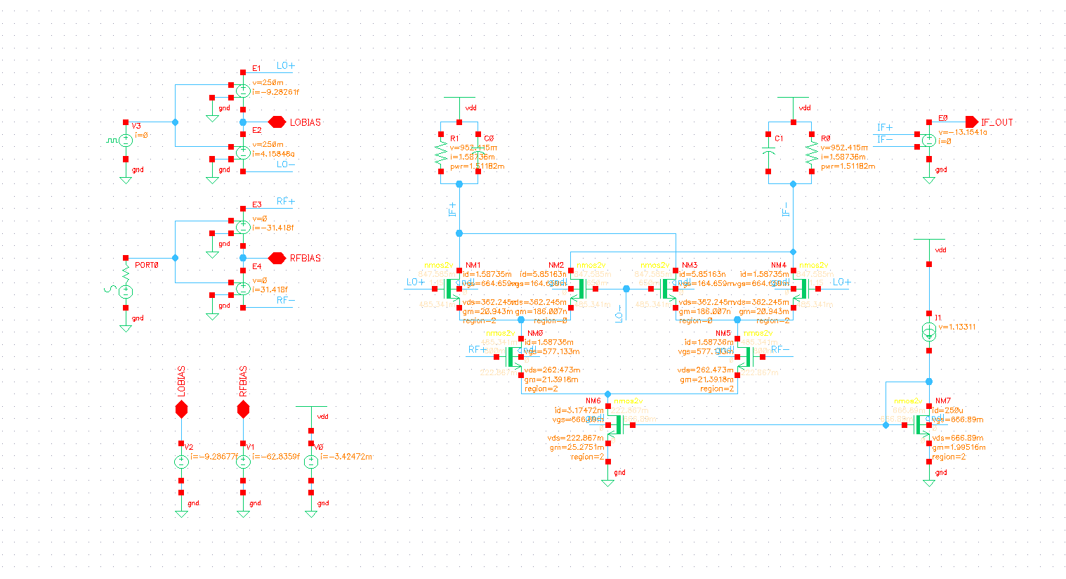**Fig. 2. DC operating points (after running dc analysis)**

1. **PSS Simulation:**

|  |
| --- |
| **Conversion Gain** (at -30 dBm input)  = -23.408– (-33.979)  = **10.571 dB** |

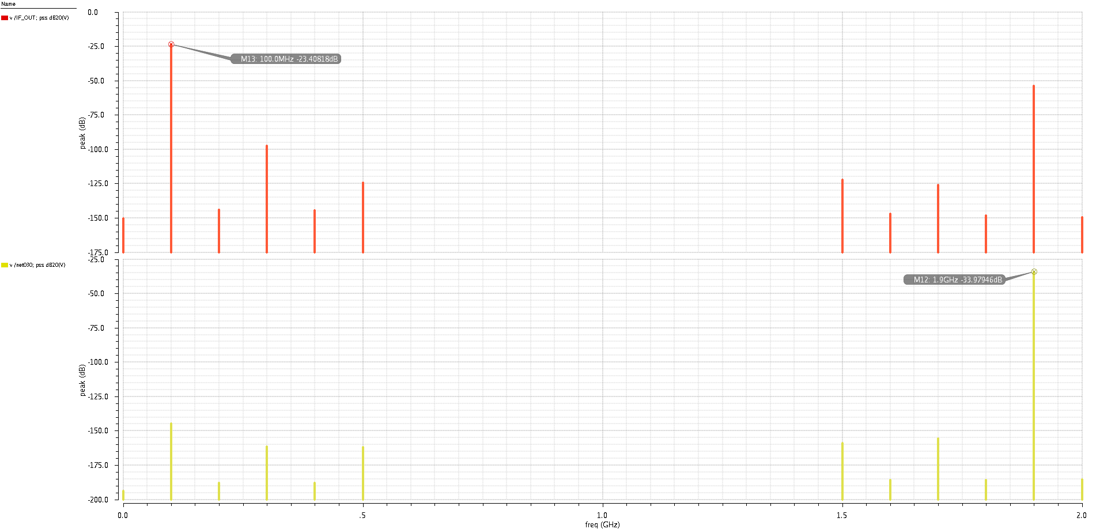

Input (RF) spectrum

Output (IF) spectrum

**Fig. 3. Output & Input Spectrum**

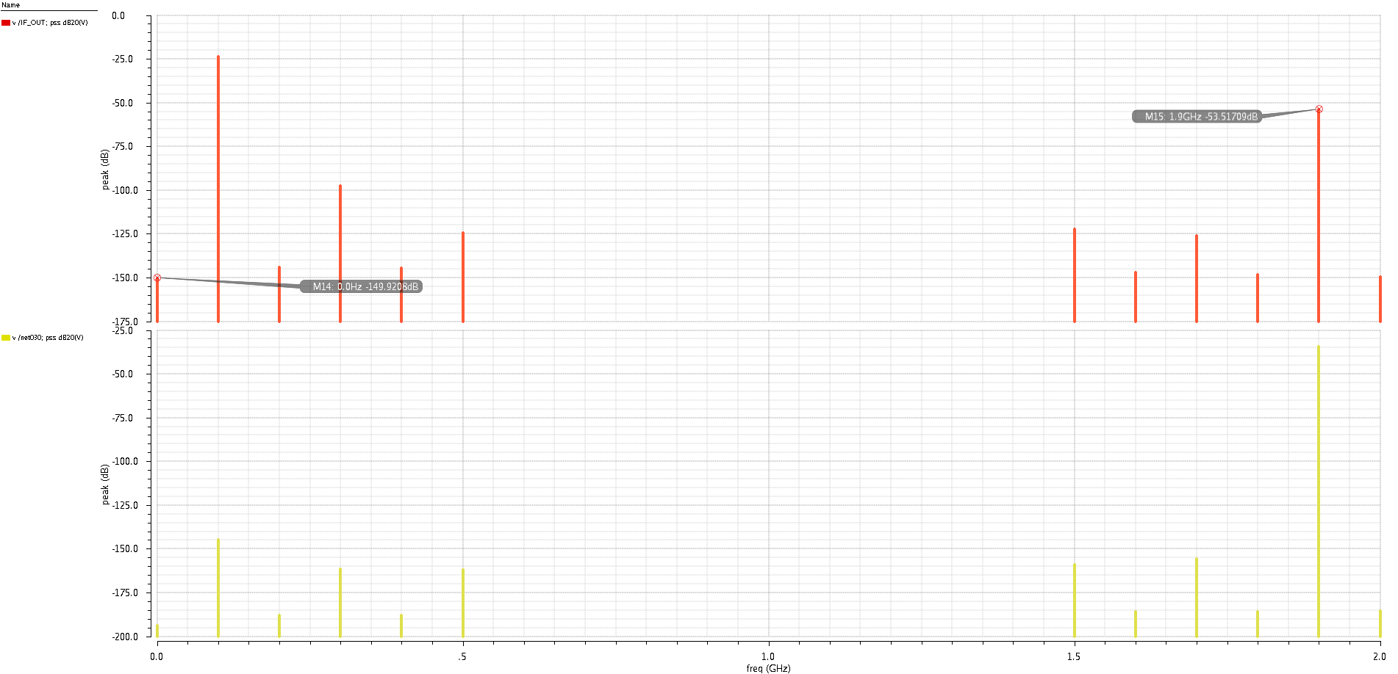

Due to some RF leaking into the output.  
(this can be removed by filtering in the next stages)

Due to self-mixing of the LO leakage with itself

Input (RF) spectrum

Output (IF) spectrum

**Fig. 4. Undesired Output Spectrum**

1. **PNoise Simulation:**

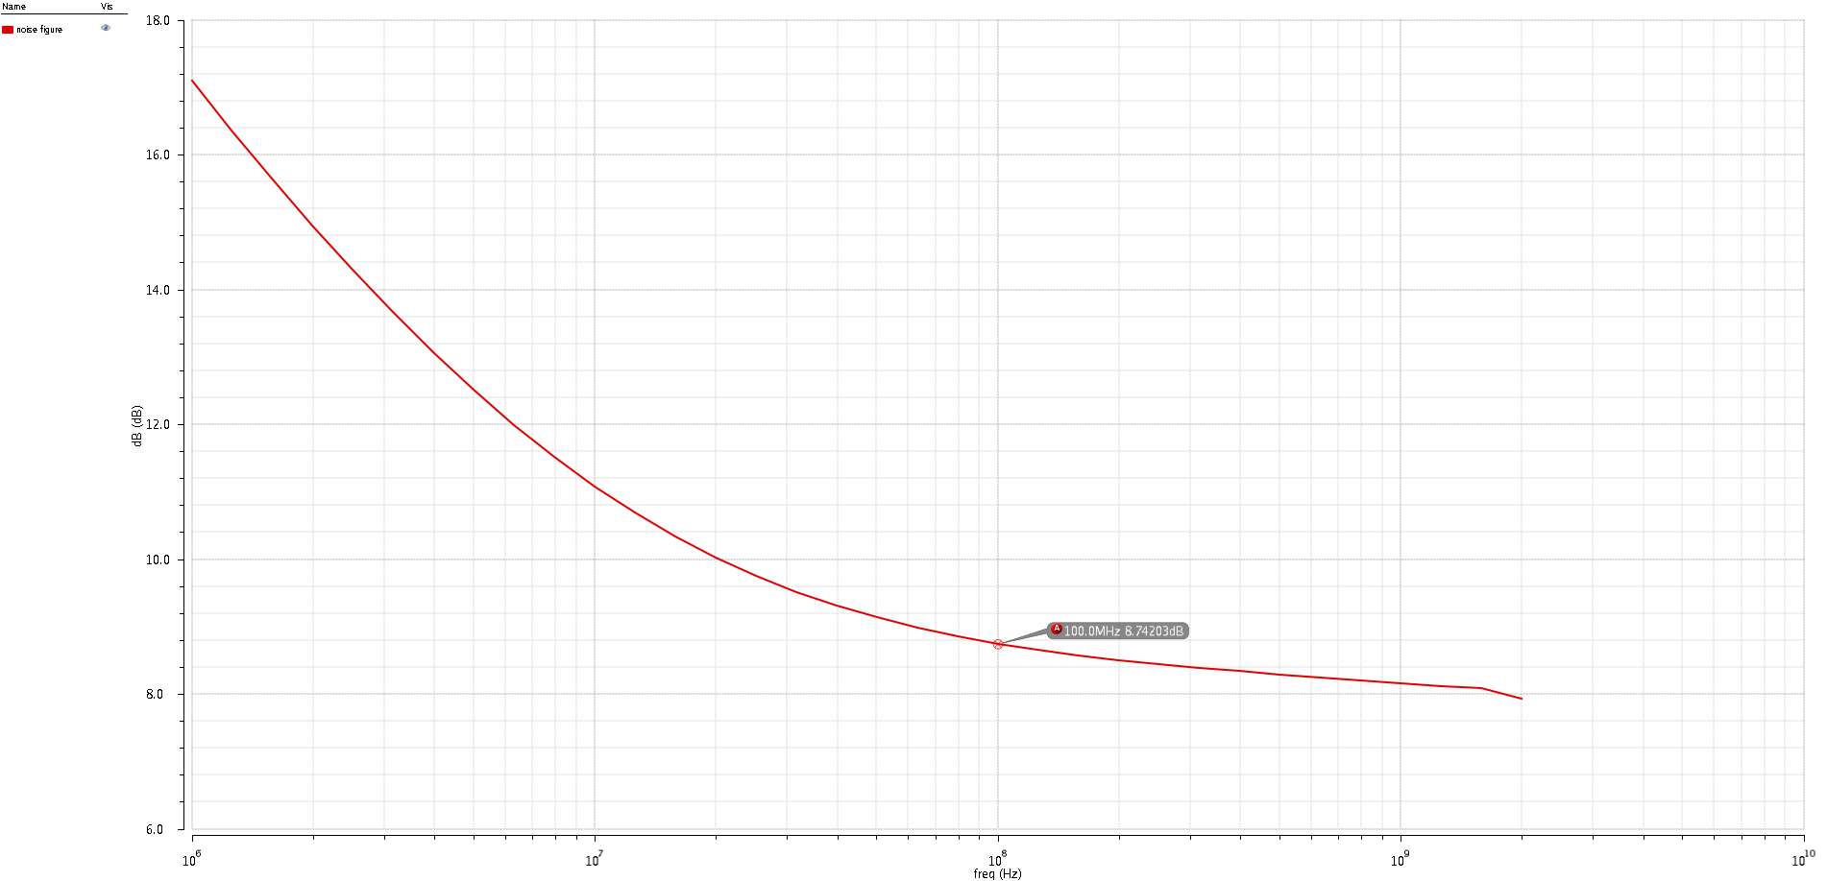

|  |
| --- |
| **NF** (at 100MHz output) = **8.74 dB** |

Noise Figure

**Fig. 5. Noise Figure of the Mixer**

1. **SPSS Simulation:**

|  |
| --- |
| **CG** (at -30dBm input) = **10.57 dB**  **CG** (at -10dBm input) = **6.804 dB** |

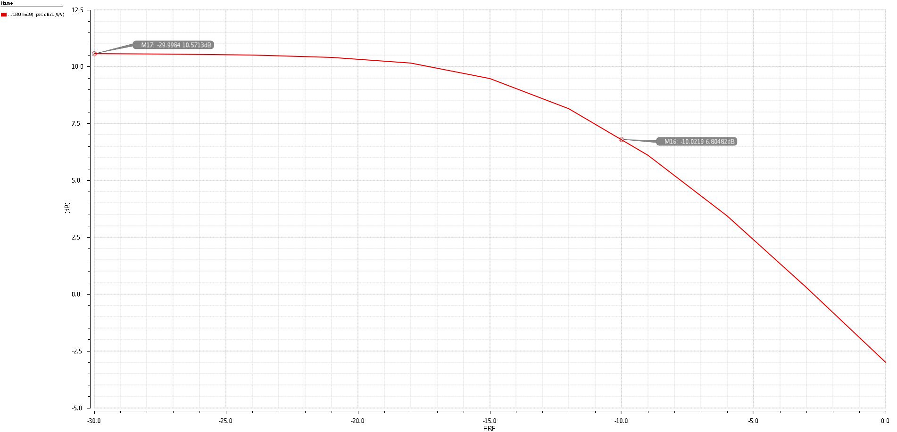

Conversion Gain

**Fig. 6. Conversion Gain Vs Input Power**

1. **QPSS & QPAC Simulation:**

|  |
| --- |
| **P1dB** point = **-15.432 dB** |

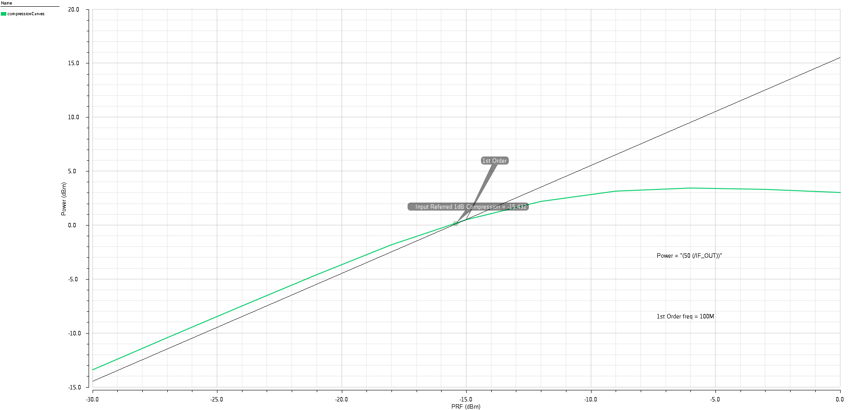

1dB Compression curve

**Fig. 7. Output Power Vs Input Power   
(Compression curve)**

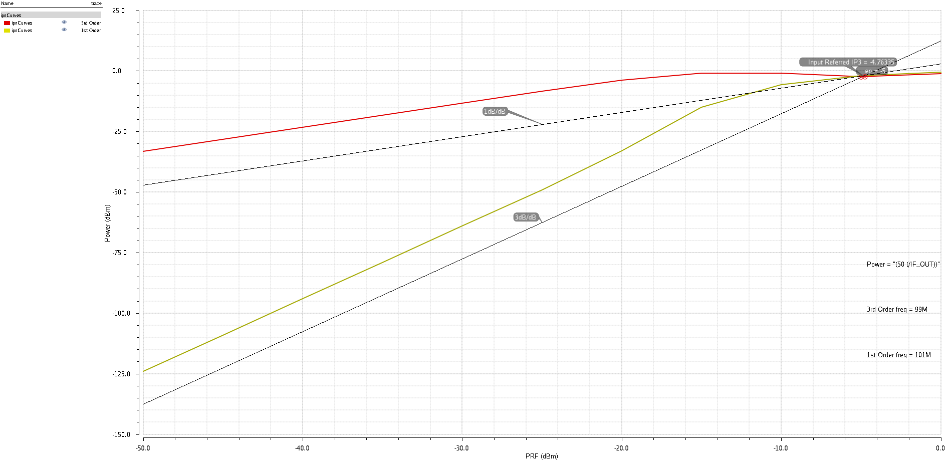

3rd Order Curve  
1st Order Curve

**Fig. 8. Fundamental & 3rd-order Output Power Components Vs Input Power from the 2-tone test  
(IPN curves)**

1. **Summary of the results:**

|  |  |
| --- | --- |
| **Parameter** | **Value** |
| Power Dissipation | 3.42 mA * 1.8 V = **6.16 mW** |
| Conversion Gain (@ -30 dBm) | **10.57 dB** |
| Noise Figure | **8.74 dB** |
| P1dB Compression Point | **-15.43 dBm** |
| IIP3 | **-4.76 dBm** |